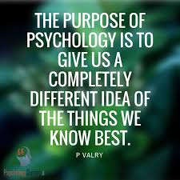

AS Level Psychology

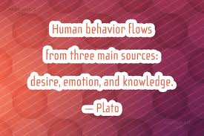

What is psychology?
Psychology can be defined as the science of the mind. The human mind is the source of all thought and behaviour and is highly complex.
But what is the mind, where is it located and how can we study something that is this complex and mysterious? We cannot see someone thinking, nor can we observe their emotions, or memories, or perceptions and dreams. So how do psychologists go about studying the mind?
In fact, psychologists adopt a similar approach to other scientists. They study what they can see, in this case, behaviour. Psychologists use human behaviour as a clue to the workings of the mind. Although we cannot observe the mind directly, everything we do, think, feel and say is determined by the functioning of the mind. So psychologists take human behaviour as the raw data for developing and testing their theories about how the mind works.
Psychology aims to explain behaviour and does so from a number of perspectives or approaches including the following:
- Cognitive approach
- Biological approach
- Behaviourist approach
- Psychodynamic approach
- Positive approach
- Developmental approach
- Social approach
Each approach gives a different and often contrasting explanation for behaviour. During the AS course, you will study most of these approaches and will be presented with evidence supporting each one. Most of the evidence comes from research studies and you will also learn about the research methods that psychologists use to carry out these studies. More details of the AS specification are included later in this booklet.
For many of you, psychology will be a new subject that you have not studied before. It would therefore be particularly beneficial for you to familiarise yourselves with the subject and the course and to get a head start by completing some of the tasks in this booklet.
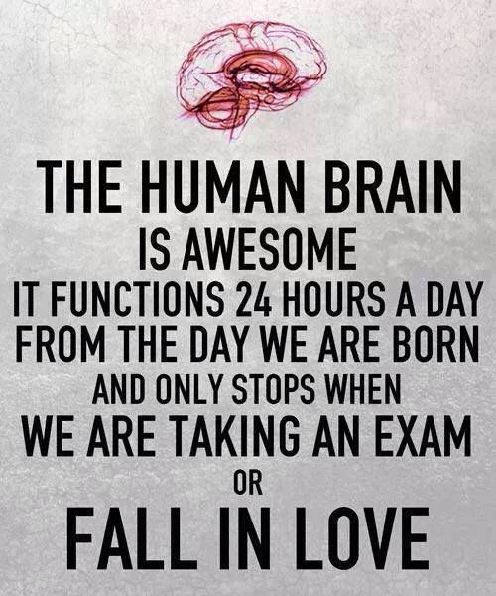

Fascinating books to read
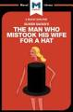
Here Dr. Sacks recounts the case histories of patients lost in the bizarre, apparently inescapable world of neurological disorders: people afflicted with fantastic perceptual and intellectual aberrations; patients who have lost their memories and with them the greater part of their pasts; who are no longer able to recognize people and common objects; who are stricken with violent tics and grimaces or who shout involuntary obscenities; whose limbs have become alien; who have been dismissed as retarded yet are gifted with uncanny artistic or mathematical talents.
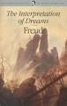
The Interpretation of Dreams is an 1899 book by Sigmund Freud, the founder of psychoanalysis, in which the author introduces his theory of the unconscious with respect to dream interpretation, and discusses what would later become the theory of the Oedipus complex.

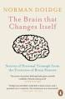
The Brain that Changes Itself is about the revolutionary discovery that the human brain can change itself, as told through the stories of the scientists, doctors, and patients who have together brought about these astonishing transformations. Without operations or medications, they have made use of the brain's hitherto unknown ability to change. Some were patients who had what were thought to be incurable brain problems; others were people without specific problems who simply wanted to improve the functioning of their brains or preserve them as they aged.
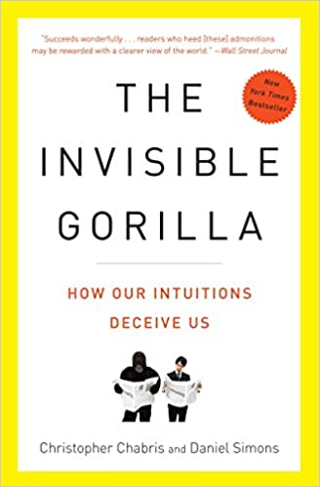
Reading this book will make you less sure of yourself—and that’s a good thing. In The Invisible Gorilla, Christopher Chabris and Daniel Simons, creators of one of psychology’s most famous experiments, use remarkable stories and counterintuitive scientific findings to demonstrate an important truth: Our minds don’t work the way we think they do. We think we see ourselves and the world as they really are, but we’re actually missing a whole lot. Chabris and Simons combine the work of other researchers with their own findings on attention, perception, memory, and reasoning to reveal how faulty intuitions often get us into trouble
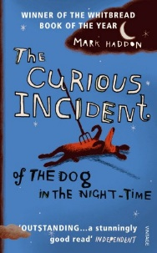
The Curious Incident of the Dog in the Night-Time is a murder mystery novel like no other. The detective, and narrator, is Christopher Boone. Christopher is fifteen and has Asperger's Syndrome. He knows a very great deal about maths and very little about human beings. He loves lists, patterns and the truth. He hates the colours yellow and brown and being touched. He has never gone further than the end of the road on his own, but when he finds a neighbour's dog murdered he sets out on a terrifying journey which will turn his whole world upside down

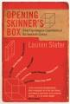
A century can be understood in many ways - in terms of its inventions, its crimes or its art. In Opening Skinner's Box, Lauren Slater sets out to investigate the twentieth century through a series of ten fascinating, witty and sometimes shocking accounts of its key psychological experiments. Starting with the founder of modern scientific experimentation, B.F. Skinner, Slater traces the evolution of the last hundred years' most pressing concerns - free will, authoritarianism, violence, conformity and morality. Previously buried in academic textbooks, these often daring experiments are now seen in their full context and told as stories, rich in plot, wit and character.
Entertaining movies to enjoy

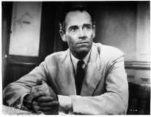
“12 Angry Men”
Topics: Social, moral development
Plot: A diverse group of 12 jurors deliberates the fate of an 18-year-old Latino accused of murdering his father. As a lone dissenting juror tries to convince the others that the case is not as open-and-shut as it appears, individual prejudices and preconceptions about the trial emerge.

“28 Days”
Topics: Substance abuse disorders/alcoholism
Plot: Sandra Bullock plays a newspaper columnist who chooses to enter a rehabilitation center for alcoholism in lieu of jail time for stealing a limousine at her sister’s wedding and crashing it. Initially in denial that she is an alcoholic and resistant to treatment, with the help of fellow patients, she eventually begins to re-examine her life and comes to terms with her alcoholism and addiction to prescription medications.
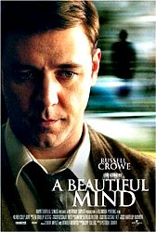
“A Beautiful Mind”
Topics: Abnormal psychology, psychotic disorders/schizophrenia
Plot: Based on the life of mathematical genius and Nobel Laureate John Forbes Nash, who suffers from severe mental illness, this film won four Academy Awards including Best Picture.
The film sheds light on the life and suffering of a person living with schizophrenia. Psychology students will notice that Nash exhibits many of the symptoms used to diagnose schizophrenia and can follow the increasing intensity of these symptoms and the effect on him and those around him. The film also shows the difficult task of managing the disorder and the importance of social support.
“Good Will Hunting”
Topics: Social and developmental psychology, treatment, giftedness
Plot: Will Hunting is a young, headstrong janitor at MIT with exceptional mathematical abilities. Abused as a child, he has numerous run-ins with the law and does not realize his full potential. With the help of a psychology professor, he finally receives the counselling he needs that will enable him to find his identity and change his life. This movie depicts a difficult therapeutic relationship between an ambivalent client and a somewhat unorthodox counsellor.

“Identity”
Topics: Psychotic disorders, forensic psychology
Plot: A group of strangers from different walks of life are forced to find shelter during a torrential rainstorm at an out-of-the-way Nevada desert motel. One-by-one, they are killed off. Meanwhile, in a related storyline, a psychiatrist tries to prove the innocence of a man accused of murder. “Identity” deals with a unique and controversial disorder (it’s a spoiler if I name it). It plays on some misconceptions about the disorder, but has a radical therapy suggestion that is intriguing. It is also an exciting murder mystery.

“Memento”
Topics: Neuropsychology, memory loss/amnesia
Plot: Leonard Shelby is an ex-insurance investigator who sustains a head injury when trying to prevent his wife’s murder and now suffers from amnesia. He learns how to cope with his condition using notes and tattoos as he tries to find the murderer and avenge her death. “Memento” deals with a person with short-term memory loss trying to solve a mystery. It is accurate, in many ways, regarding what life might be like for someone who cannot remember for more than a few minutes or seconds at a time. It is fascinating in a cognitive sense, as well as moving and emotionally engaging (and exciting).
“On Golden Pond”
Topics: Neuropsychology/dementia, marital/family dynamics
Plot: This Academy Award winner for Best Actor and Best Actress tells the story of elderly couple, Norman and Ethel Thayer, who return to their summer cottage while dealing with Norman’s failing memory, onset of senility and strained relationship with his daughter. This movie is full of great explorations of so many fundamental aspects of human nature, including family relationships, aging, death and dying, personal growth, and forgiveness.
“One Flew Over the Cuckoo’s Nest”
Topics: Personality/mood disorders, forensic psychology, treatment
Plot: Randle McMurphy has a criminal past. To escape his most current prison sentence, he pleads insanity so that he can be sent to a mental institution where he thinks he can serve his sentence more comfortably than in jail. Upon admittance, he rallies the other patients into rebellion against the oppressive Nurse Ratched.This Academy Award-winning classic is a must-see film for psychology students. It provides a disturbing look into mental hospitals in the 1960s, including electroshock therapy as a form of treatment and a dysfunctional form of group psychotherapy.

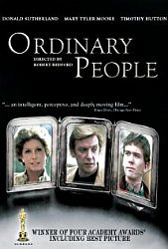
“Ordinary People”
Topics: Family dynamics, stress and coping, mood disorders, therapy
Plot: When his older brother dies unexpectedly, guilt and grief push Conrad Jarrett to attempt suicide. After spending six months in a mental hospital, he returns home, sees a psychiatrist, and tries to return to normal. His parents each react differently to the trauma; his father attempts to deal with his grief, while his mother remains in denial, angry and depressed. This film sheds realistic light on how one family deals with trauma and the resulting breakdown of the family unit. It offers a positive, affirming portrayal of a therapist and the value of therapy in helping Conrad and his father heal.
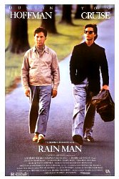
“Rain Man”
Topics: Neuropsychology/autism, marital/family dynamics
Plot: “Rain Man” is the story of a hustler, Charlie Babbit, and his brother, Raymond, an autistic savant unknown to Charlie who is living in an institution. When the brothers’ father dies and leaves his fortune in trust to Raymond, Charlie sets out on a scheme to gain custody of Raymond and control of the money during a classic cross-country road trip.This film shed light on autism at time when there was little public awareness of the syndrome. Raymond exhibits many of the classic behaviors of a high-functioning autistic.

“Regarding Henry”
Topics: Neuropsychology, retrograde amnesia, marital/family dynamics
Plot: Henry is a hard-driven lawyer who is shot in the head during a robbery and suffers brain damage. He emerges from a coma with retrograde amnesia. As he struggles to recover his speech and mobility and regain his memory, he experiences a shift in values and builds a new life for his family and himself. While real-life cases of retrograde amnesia are actually quite rare, films tend to depict it as fairly common occurrence and, therefore, often promote inaccuracies. Despite that fact, this movie does a good job showing how retrograde amnesia can have a significant impact on individuals and their families – sometimes for good or ill.

“Reign Over Me”
Topics: Post-traumatic stress disorder
Plot: The grief that Charlie Fineman experiences after losing his family in the September 11 attack on New York City causes him to quit his job and isolate himself. After a chance encounter, he rekindles his friendship with his old college roommate, Alan Johnson, who helps him to face his past and rebuild his life. "Rein Over Me" is an entertaining movie, replete with laughs and more sober, thought-provoking scenes, but it also demonstrates some of the ways in which PTSD can impact the life of the affected individual as well as everyone in his or her life.

Thought provoking Ted Talks to watch
History v Sigmund Freud
https://www.ted.com/talks/todd_dufresne_history_vs_sigmund_freud?utm_campaign=tedspread&utm_medium=referral&utm_source=tedcomshare
Philip Zimbardo: The Psychology of Evil
https://www.ted.com/talks/philip_zimbardo_the_psychology_of_evil
Martin Seligman: The New Era of Positive Psychology
https://www.ted.com/talks/martin_seligman_the_new_era_of_positive_psychology
Mihaly Csikszentmihalyi: Flow
https://www.ted.com/speakers/mihaly_csikszentmihalyi
Peter Mende-Siedlecki: First Impressions
https://www.ted.com/talks/peter_mende_siedlecki_should_you_trust_your_first_impression
Peggy Andover: The difference between Classical and Operant Conditioning
https://www.ted.com/talks/peggy_andover_the_difference_between_classical_and_operant_conditioning
Elizabeth Loftus: How Reliable is your Memory?
https://www.ted.com/talks/elizabeth_loftus_how_reliable_is_your_memory?utm_campaign=tedspread&utm_medium=referral&utm_source=tedcomshare
Helen Fisher: Evolution of Human Emotions
https://www.ted.com/speakers/helen_fisher
Jim Fallon: Exploring the mind of a Killer
https://www.ted.com/talks/jim_fallon_exploring_the_mind_of_a_killer?utm_campaign=tedspread&utm_medium=referral&utm_source=tedcomshare
Eleanor Nelsen: Would you Sacrifice one Person to Save Five?
https://www.ted.com/talks/eleanor_nelsen_would_you_sacrifice_one_person_to_save_five
Steven Pinker: Human Nature and the Blank Slate https://www.ted.com/talks/steven_pinker_human_nature_and_the_blank_slate?utm_campaign=tedspread&utm_medium=referral&utm_source=tedcomshare
Dawn Maslar: The Science of Attraction
https://www.ted.com/talks/dawn_maslar_the_science_of_attraction
Tom Griffiths: Three Ways to make Better Decisions by Thinking like a Computer
https://www.ted.com/talks/tom_griffiths_3_ways_to_make_better_decisions_by_thinking_like_a_computer?utm_campaign=tedspread&utm_medium=referral&utm_source=tedcomshare

WJEC AS Level Psychology Specification
Unit 1: Psychology Past to Present
- Written examination: 1 hour 30 minutes
- 20% of A Level qualification (50% of AS qualification)

The purpose of this unit is to give a solid grounding in some of the basic core elements of psychology. The intention is to allow the learner, through the study of classic research to gain an appreciation that psychology continues to develop and evolve. The early ideas should not be dismissed but rather studied in context with consideration of the advances made in more recent years. For each of the five psychological approaches (biological, psychodynamic, behaviourist, cognitive and positive) it will be necessary for learners to:
- know and understand the assumptions
- apply the assumptions to explain the formation of a relationship
- know and understand how the approach can be used in therapy (one therapy per
- approach)
- know and understand the main components of the therapy
- evaluate the therapy (including its effectiveness and ethical considerations)
- evaluate the approach (including strengths, weaknesses and comparison with the
- four other approaches)
- know, understand and make judgements on a classic piece of evidence
- (including methodology, procedures, findings, conclusions and ethical issues and
- social implications).

Unit 1: Content
Approach | Assumptions and behaviour to be explained | Therapy | Classic research
Biological | - evolutionary influences  - localisation of brain function  - neurotransmitters  - formation of relationships (e.g. siblings) | Drug therapy  or  Psychosurgery | Raine, A., Buchsbaum, M. and LaCasse, L. (1997) Brain abnormalities in murderers indicated by positron emission tomography.
Psychodynamic | - influence of childhood experiences  - the unconscious mind  - tripartite personality  - formation of relationships (e.g. mother and child) | Dream analysis  or  Group analysis psychotherapy | Bowlby, J. (1944) Forty-four juvenile thieves: Their characters and home-life.
Behaviourist | - blank slate  - behaviour learnt through conditioning  - humans and animals learn in similar ways  - formation of relationships (e.g. pet and owner) | Aversion therapy  or  Systematic desensitisation | Watson, J.B. and Rayner, R. (1920) Conditioned emotional reactions.
Cognitive | - computer analogy  - internal mental processes  - schemas  - formation of relationships (e.g. romantic) | Cognitive behavioural therapy  or  Rational emotive behaviour therapy | Loftus, E. and Palmer, J.C. (1974) Reconstruction of automobile destruction: an example of the interaction between language and memory.
Positive | - acknowledgement of free will  - authenticity of goodness and excellence  - focus on ‘the good life'  - formation of relationships (e.g. friends) | Mindfulness  or  Quality of life therapy | Myers, D.G. and Diener, E. (1995) Who is happy? Psychological

Unit 2: Using Psychological Concepts
- Written examination: 1 hour 30 minutes
- 20% of A Level qualification (50% of AS qualification)

Section A - Contemporary debate
The explorations of five contemporary debates provide an opportunity for independent research into areas that psychology has influenced. Both sides of the debate should be considered from a psychological perspective (including the ethical, social and economic implications as well as the consideration of social and cultural diversity). Learners are asked to explore the debates using their knowledge and understanding of the five approaches in Unit 1. This section provides an opportunity to consider psychological work carried out in Wales.

Contemporary debates:
- The ethics of neuroscience
- The mother as primary care-giver of an infant
- Using conditioning techniques to control the behaviour of children
- Reliability of eye-witness testimony (including children)
- Relevance of positive psychology in today’s society

Section B - Principles of research and application of research methods
Principles of research:
The focus for this section is that of psychological research, from the initial planning stages through to the final stage of analysis and evaluation. It is designed to introduce candidates to the methodologies used by psychologists in working scientifically and to gain an appreciation of the impact of choices made on the outcomes of the work and consequently the possible applications. Learners should appreciate the limitations of scientific research and when dealing with the complexities of humans as test material, there are several issues which need to be considered. To achieve this appreciation learners are encouraged to carry out appropriately supervised, ethical investigations. To give an appropriate context for the teaching, two pieces of research from the work of social and developmental psychologists should be studied.
Application of research methods to a novel scenario:
This section requires learners to apply their knowledge and understanding of research methods to a novel research scenario, making judgements on the details of psychological research

Useful tasks to attempt
- Read up on the following psychological approaches and write a sentence on each, summarising how the approach explains behaviour:
- Cognitive approach
- Behaviourist approach
- Biological approach
- Psychodynamic approach
- Positive approach

- Research the following therapies and write a half page summary of them:
- Drug therapy
- Psychosurgery
- Dream analysis
- Group analysis psychotherapy
- Aversion therapy
- Systematic desensitisation
- Cognitive behavioural therapy
- Rational emotive behaviour therapy
- Mindfulness
- Quality of life therapy
See if you can find any YouTube clips of these therapies being used

- Draw a diagram of the brain and learn the names of the different brain areas

- Read up on Freud’s Tripartite Theory of Personality

- Research the nature v nurture debate and summarise the main arguments for each side of the debate. Do you think criminals are born or made?

- Find out about mindfulness and practice a mindfulness activity

- Research Stanley Milgram and see what you can find out about his studies into obedience

- Watch one of the movies listed above and write half a page on what it tells us about human behaviour. Which of the psychological approaches could you link to the behaviour?

- Which of the Ted Talks did you find most interesting? What did you learn from it?

- Read the scenario below and think about what you would do and the reasons why
- Design a questionnaire to measure stress levels and design an experiment using this questionnaire to see whether parents or students are more stressed in the weeks leading up to a A level exams.

- Write a hypothesis for this study (a statement predicting what you would expect the outcome of this study to be)

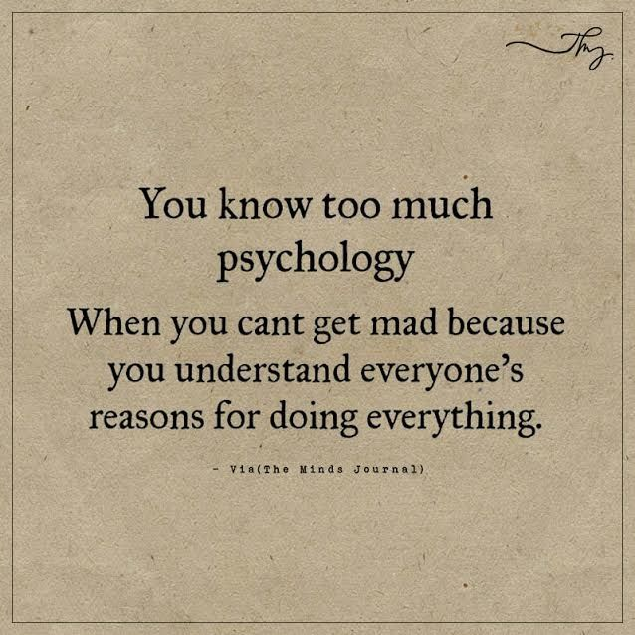

Twitter accounts to follow

@PsychToday

@psychpodcast

@BPSOfficial

@peterkinderman
@PsyBlog
@TVpsychologist
@Psych_Writer
@Psychreg
@PaulEkman
@sjblakemore
@LouiseChunn
@Welldoing_Org
@MindCharity

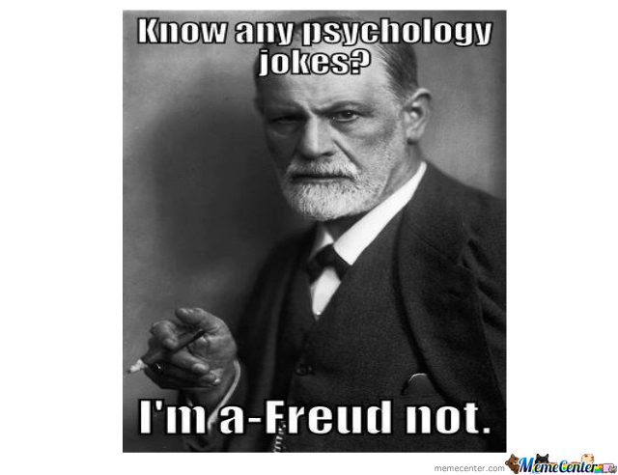
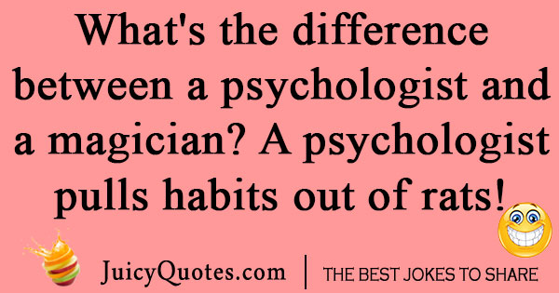
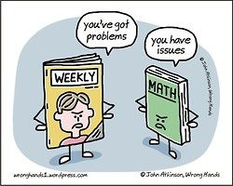
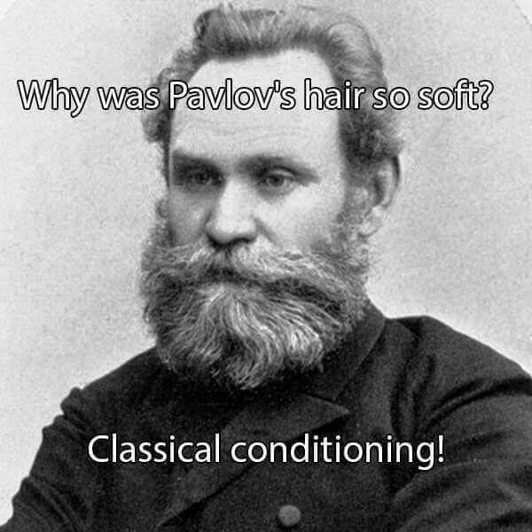
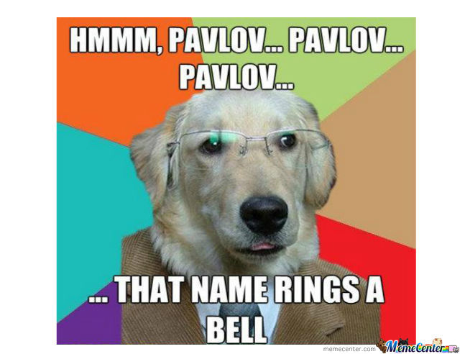
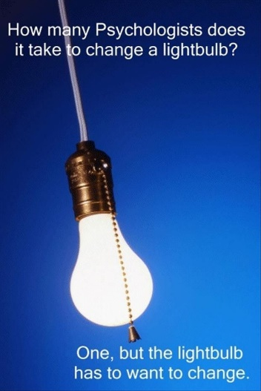
To make you chuckle (or groan)!!

