UG CYMRAEG

(Ail Iaith)

[](https://www.google.co.uk/url?sa=i&url=https%3A%2F%2Fwww.redbubble.com%2Fi%2Fposter%2FCymraeg-by-DafyddEm%2F40150452.LVTDI&psig=AOvVaw1ZtLfzcSnneQ57uHnw-5WI&ust=1590072712869000&source=images&cd=vfe&ved=0CAIQjRxqFwoTCKC87M7YwukCFQAAAAAdAAAAABAE)

Y cam nesaf …

**Pam dysgu Cymraeg?**

**Dyma adeg mor gyffrous yn hanes ein hiaith a bydd cymhwyster uwch yn y Gymraeg yn gallu agor drysau a chyfleoedd gwbl newydd i chi.**

**Mae’n gwrs diddorol, deinamig fydd yn eich harwain ar daith drwy hanes Cymru, ei hiaith a’i llenyddiaeth. Hefyd fydd yna daith bersonol i chi ddod yn rhugl ac yn un o’r miliwn – targed siaradwyr Cymraeg Llywodraeth Cymru. Felly, yn sicr mae astudio’r Gymraeg yn fwy berthnasol heddiw nag erioed.**

**Rhydd y cymhwyster fanteision di-ri wrth ystyried dewisiadau addysg uwch ac hefyd gyrfaoedd gwahanol a’r gallu i weithredu yn ddwyieithog. Dyna’r gwir yn syml – dwy iaith, dwywaith y dewis.**

[](https://www.google.co.uk/url?sa=i&url=https%3A%2F%2Fwww.gamesquest.co.uk%2Fblog%2Fst-patricks-giveaway-two-superb-board-games%2F&psig=AOvVaw0QbyB2NZIVlJEy8yU_7lJT&ust=1590499697679000&source=images&cd=vfe&ved=0CAIQjRxqFwoTCOCQgaGPz-kCFQAAAAAdAAAAABAE)

Why learn Welsh?

This is one of the most exciting times in the history of our language and gaining a higher qualification in Welsh will open doors and offer you new opportunities.

The course is interesting and dynamic which will lead you on a journey through the history of Wales, her language and literature. Also there will be a personal journey to gain fluency as one of the million – the Welsh Government’s target for Welsh speakers. Studying Welsh has never been more relevant than it is today.

This qualification offers innumerable advantages when considering higher education choices and the different career opportunities with the ability to work bilingually. It’s a simple truth – two languages – twice the choice.

**Crynodeb y cwrs Safon UG?** (A summary of the AS Course?)

**UNED 1 (15%)**

|  |  |
| --- | --- |
| **Arholiad llafar**  An oral Examination | **Adran A : Gwaith grŵp : Trafod ffilm (tua 20 munud)**  **Adran B : Llafar unigol : Ymateb i destun uned 2 (tua 5 munud)**  Section A : Group Work : Discuss a film (approx. 20 mins)  Section B : Individual oral : Respond to the unit 2 topic (approx. 5 mins) |

**UNED 2 (10%)**

|  |  |
| --- | --- |
| **Asesiad di-arholiad**  **(gwaith cwrs)**  Non-examination assessment  (coursework) | **Ysgrifennu 3 darn estynedig ar dopig o ddewis personol.**  **Cyfanswm : 1500 – 2000 gair**  Write 3 extended pieces of work on a topic of choice  Total : 1500 – 200 words |

**UNED 3 (15%)**

|  |  |
| --- | --- |
| **Arholiad ysgrifenedig**  Written Examination  **(2 awr)** | **Adran A : Gwaith iaith – tasgau iaith amrywiol**  **Adran B : Barddoniaeth**  Section A : The use of language – varied language tasks  Section B : Poetry |

**Manyleb CBAC** [**WJEC Syllabus**](https://www.wjec.co.uk/media/4ohbsvel/wjec-gce-welsh-second-language-spec-from-2016-e-1.pdf)

**IAITH / GRAMADEG**

[](https://www.google.co.uk/url?sa=i&url=https%3A%2F%2Fcommons.wikimedia.org%2Fwiki%2FFile%3AHelpicon.svg&psig=AOvVaw3KwuSdzmdN1qxYKSkKqoqJ&ust=1590486349686000&source=images&cd=vfe&ved=0CAIQjRxqFwoTCPCJo8bdzukCFQAAAAAdAAAAABAJ)

[**Pecyn Gramadeg Peniarth**](https://hwbwave15-my.sharepoint.com/:b:/g/personal/thomast231_hwbcymru_net/EaGnOUd8QFZFuLsilP3cscMBugvzsf304R2n_WcAalPXmw?e=4QBjgE) **:** Pecyn adolygu gramadeg (revision pack)

[**Pecyn Gramadeg**](https://resources.hwb.wales.gov.uk/VTC/2009-10/welsh/tinopolis/swf/main/default.htm): Pecyn ar gyfer dysgwyr (specifically for learners)

[**Pecyn Iaith**](https://resources.hwb.wales.gov.uk/VTC/ngfl/welsh/127/index.html) **:** Rheolau gramadeg ac enghreifftiau (rules and examples)

[**Ap Sglein**](https://apps.apple.com/us/app/ap-sglein/id964493801): Pecyn mwy uchelgeisiol (an indepth grammar pack)

**Ymarferion Iaith** (language exercises)

1. Newid i’r lluosog (Change to the plural) [Newid i'r lluosog](https://forms.office.com/Pages/ResponsePage.aspx?id=Ug4_TzS3ZEGUCRtgHRR5kymQs3suwqpEhKkJW6zyI_tUQkZLWkpPR0kzS0xWRzdaQTlNNDFTT1NMSC4u)
2. Newid i’r gorffennol (Change to past tense) [Gorffennol](https://forms.office.com/Pages/ResponsePage.aspx?id=Ug4_TzS3ZEGUCRtgHRR5kymQs3suwqpEhKkJW6zyI_tUNlU1VldFTTlMMzVWRFJXWkZBRzlHQ0ZMSi4u)
3. Newid i’r 3ydd person (Change to the 3rd person) [Wynne Evans](https://forms.office.com/Pages/ResponsePage.aspx?id=Ug4_TzS3ZEGUCRtgHRR5kymQs3suwqpEhKkJW6zyI_tUNzlWWUlPVUhFSjRIM1hDVkJMOTJURThYWi4u)
4. Newid i’r 3ydd person (Change to the 3rd person) [Ruth Jones](https://forms.office.com/Pages/ResponsePage.aspx?id=Ug4_TzS3ZEGUCRtgHRR5kymQs3suwqpEhKkJW6zyI_tUNE1IMFQ0V0dSSE1QOFpOMVhIR1hIWEtPQS4u)
5. Newid i’r 3ydd person (Change to the 3rd person) [3ydd person](https://forms.office.com/Pages/ResponsePage.aspx?id=Ug4_TzS3ZEGUCRtgHRR5kymQs3suwqpEhKkJW6zyI_tUMUdVRjdVRDg3Vkg4NDQ0U0ZNVDZaREhWUi4u)
6. Newid i’r gorffennol (Change to the past tense) [Newid i'r gorffennol](https://forms.office.com/Pages/ResponsePage.aspx?id=Ug4_TzS3ZEGUCRtgHRR5kymQs3suwqpEhKkJW6zyI_tUNTFRRzRIN1cwQklMVURaTzU1NFREQVQ3OS4u)

**Llyfrau Gramadeg Posibl** (Possible Grammar Books)

*Y Chwiliadur Iaith* : Non ap Emlyn (detailed grammar resource)

*Verbots* : Rory Ryder (101 Welsh verbs)

*Learn Welsh :* Grammar Guide BBC

*Seren Iaith 1* : Nona Breese & Bethan Clement

*Seren Iaith 2* : Nona Breese & Bethan Clement

(grammar rules with help sheets and tasks)

*Cymraeg Da* **:** Heini Gruffydd (grammar exercises)

**YouTube**

[Treiglad Meddal](https://www.youtube.com/watch?v=8fjUdJqa5Hg)

[Treiglad Trwynol](https://www.youtube.com/watch?v=pjGcf9PvBDY)

[Berfau'r Gorffennol](https://www.youtube.com/watch?v=QSyi2S_cEi0)

* Athro Cymraeg (numerous podcasts on language, films, poetry …)
* Bethan Cambourne (fitness)
* Cymreigio (language)

[](https://www.google.co.uk/url?sa=i&url=https%3A%2F%2Fphys.org%2Fnews%2F2019-07-instagram-group-chats-sticker-stories.html&psig=AOvVaw0jsABqWrwg9gUMVACA15jX&ust=1590245078506000&source=images&cd=vfe&ved=0CAIQjRxqFwoTCMCz4Nvax-kCFQAAAAAdAAAAABAD)[](https://www.google.co.uk/url?sa=i&url=https%3A%2F%2Fslack.com%2Fapps%2FA0F7XDW93-twitter&psig=AOvVaw0TiG2vLP7QHCIJ7rvdB18k&ust=1590491638802000&source=images&cd=vfe&ved=0CAIQjRxqFwoTCJCol5zxzukCFQAAAAAdAAAAABAD)

@urdd

@urddieuenctid

* gweiddi.org
* parallel.Cymru
* golwg360.cymru

@S4C

@S4Cstwnsh

@mentrauiaith

@BBCCymruFyw

**Apiau**

|  |  |  |
| --- | --- | --- |
| * Am | * Ap Treiglo | * Seren Iaith |
| * Anagramau | * Aur am Air | * Sillafu |
| * Ap Cywirdeb Iaith | * BBC Cymru Fyw | * Ap Sglein |
| * Ap Geiriaduron | * Brawddegau | * GPC Geiriadur |

**Rhaglenni i ddysgwyr (TV Programmes)**

[](https://www.google.co.uk/url?sa=i&url=https%3A%2F%2Fen.wikipedia.org%2Fwiki%2FS4C&psig=AOvVaw0WSuwcXaN34gcObhOcxH8w&ust=1590498287518000&source=images&cd=vfe&ved=0CAIQjRxqFwoTCNDM5v-Jz-kCFQAAAAAdAAAAABAD)

**Iaith ar Daith**

Cyfres gyda selebs sy’n dysgu Cymraeg – pobl fel Ruth Jones, Colin Jackson, Carol Vorderman a Scott Quinell. (Celebs learning Welsh)

**Cariad@iaith**

Cyfres arall gyda chriw o selebs Cymru yn treulio amser gyda’i gilydd yn dysgu Cymraeg. Y tro ma selebs fel Wynne Evans (Go Compare), Amy Wadge, Lucy Owen a Gareth Thomas (celebs following a Welsh course)

**Rhaglenni Eraill**

* Ffit Cymru
* Fferm Ffactor
* Cwpwrdd Dillad / Caru Siopa
* Heno
* Hansh

[**Clic**](https://www.s4c.cymru/clic/)(Catch up on S4C programmes on Clic e.g. Gwaith Cartref, Bang, 35 Diwrnod, Amdani)

[Y Gwyll](https://www.youtube.com/channel/UC0_lryJGA1BJ4_bYsSegBPw) (Popular detective series with subtitles : Hinterland)

[**Cip ar Glip**](https://resources.hwb.wales.gov.uk/VTC/2008-09/wsl/cip_ar_glip/c_index.html)(a series of video clips on various topics)

Ffilmiau Posibl

* [Gadael Lenin](https://www.youtube.com/watch?v=yOThBJfDlc0) (story of a group of A level students who get separated from their teachers on an art trip to Russia)
* [Hedd Wyn](https://www.youtube.com/watch?v=C8JdhAUJFt0) (the story of the WW1 poet from Trawsfynydd – with subtitles)

**DEUNYDDIAU DEFNYDDIOL ERAILL**

(Other useful resources)

[Cylchgrawn Parallel](https://parallel.cymru/cefnogi-dysgu-anffurfiol/)

**Newyddion y dydd**

@BBCCymruFyw

@golwg360

Cylchgrawn i ddysgwyr [Lingo](https://golwg360.cymru/lingo-newydd)

**Nofelau / Llyfrau**

*O Gaerfyrddin i Go Compare* : Elin Meek (story of Wynne Evans)

*Pass y Sugnydd Llwch, Darling!* : Mari George (story of Lucy & Rhodri Owen)

*Y Stryd* : Mared Lewis

*I really enjoyed the course. It means a lot to be fluent in Welsh and it’s definitely boosted my career options.*

Dw i’n rhugl erbyn hyn ac wrth fy modd fy mod i’n gallu siarad Cymraeg.

*I learnt a lot about the history and literature of Wales, but more than that I learnt about what it means to be Welsh. I enjoyed the course and have made so many enw friends now that I can use my Welsh outside the classroom*.

**Molly 18 oed Gavin 17 oed**

**Uned 1**

**Key Facts** : 60 marc (15 % of A Level qualification)

Adran A – Trafod y ffilm Patagonia mewn pâr/ grŵp o dri

Adran B – Trafod ffolio gwaith cwrs (Uned 2)

Marks are awarded by your teachers and in March/ April an external examiner will come into school to conduct the exam with you and (hopefully) confirm the marks awarded.

**Yr Arholiad**

**Adran A**

* Discuss the film – characters, themes, story, film techniques, express your opinion. Ask other group members questions to facilitate a conversation. Respond to other group members’ opinions by questioning and responding with your own personal views or by adding details. (Tua 20 munud)

**Adran B**

* Discuss your course work portfolio with the examiner. (tua 5 munud)

**PATAGONIA**

[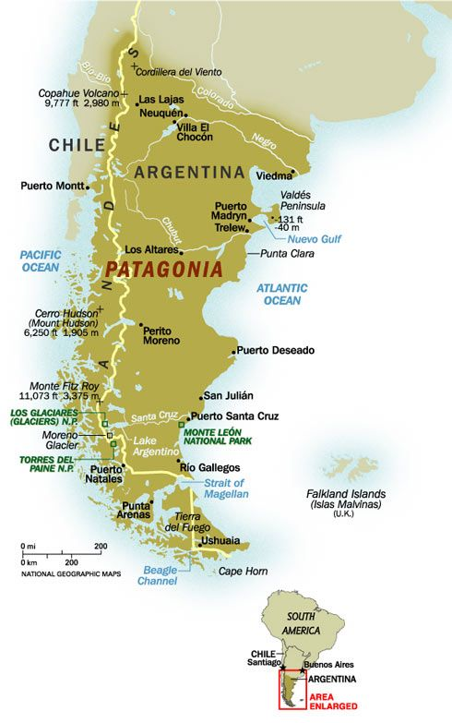](https://www.google.co.uk/url?sa=i&url=https%3A%2F%2Fwww.pinterest.com%2Fpin%2F461689399271448943%2F&psig=AOvVaw1Wuhmz1oxxuF866jFoz2zo&ust=1590567447875000&source=images&cd=vfe&ved=0CAIQjRxqFwoTCNCq49CL0ekCFQAAAAAdAAAAABAE)

Beth am ddysgu rhyw beth am Batagonia yn gyntaf?

(Firstly, what about learning something about Patagonia?)

[**Clip Fideo (Twristiaeth)**](https://www.youtube.com/watch?v=nD_dFyfOXIo)

Beth ydy’r cysylltiad rhwng Cymru a Phatagonia?

(What’s the connection between Wales and Patagonia?)

* [**BBC Hanes Patagonia**](https://www.bbc.co.uk/sounds/play/p02rw1zp)
* [**Y Cymry yn teithio i Batagonia**](https://www.youtube.com/watch?v=TrDh6F9j0mk)
* [**Y Cymry ym Mhatagonia**](https://www.youtube.com/watch?v=vh2XVwy8nf0)
* [**Dathlu taith y Mimosa**](https://www.youtube.com/watch?v=J2rkV7HH27M)
* [**Cymru a Phatagonia**](https://www.youtube.com/watch?v=nHYD1PX11u8)

[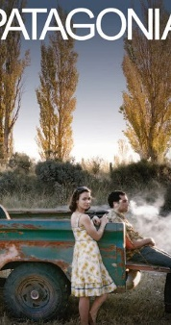](https://www.google.co.uk/url?sa=i&url=https%3A%2F%2Fwww.imdb.com%2Ftitle%2Ftt1020559%2F&psig=AOvVaw1pj-OQpPewUbZ1Q7JEeeJn&ust=1590234772345000&source=images&cd=vfe&ved=0CAIQjRxqFwoTCOix6qu0x-kCFQAAAAAdAAAAABAD)[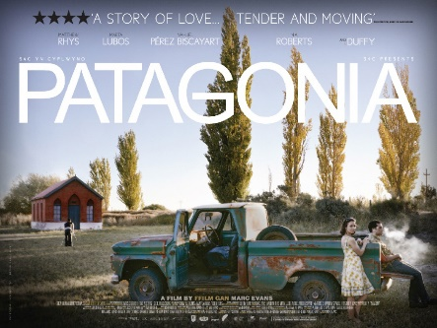](https://www.google.co.uk/url?sa=i&url=https%3A%2F%2Fwww.walesartsreview.org%2Fpatagonia-seperado%2F&psig=AOvVaw1pj-OQpPewUbZ1Q7JEeeJn&ust=1590234772345000&source=images&cd=vfe&ved=0CAIQjRxqFwoTCOix6qu0x-kCFQAAAAAdAAAAABAJ) **PATAGONIA (Ffilm Uned 1)**

Pam ysgrifennu’r ffilm Patagonia?

(Why write the film?)

Sylwadau Marc Evans (cyfarwyddwr) a’r actorion [Hanes y ffilm](https://www.youtube.com/watch?v=8P4t5uXfu4k)

(Comments by Marc Evans the director and actors)

Pa fath o ffilm ydy hi?

Gwyliwch y treilyr. [PATAGONIA (Treilyr)](https://www.youtube.com/watch?v=lBb1LfMojkE)

(What type of film is it? Watch the trailer.)

Nawr, beth am wylio’r ffilm?

[](https://www.google.co.uk/url?sa=i&url=https%3A%2F%2Fwww.nicepng.com%2Fmaxp%2Fu2q8q8q8t4q8u2e6%2F&psig=AOvVaw2f-XEop89-DP2E6QzruX3F&ust=1590230271042000&source=images&cd=vfe&ved=0CAIQjRxqFwoTCLir2sqjx-kCFQAAAAAdAAAAABAO)

Gwyliwch er pleser yn unig.

Mwynhewch!

(Relax and watch the film for pleasure. Enjoy!)

Rhan 1 [PATAGONIA Rhan 1](https://www.youtube.com/watch?v=Xahhjs3Eu8I)

Rhan 2 [PATAGONIA Rhan 2](https://www.youtube.com/watch?v=sqwqPXDxi6o)

Rhan 3 [PATAGONIA Rhan 3](https://www.youtube.com/watch?v=bTJ8M-Jfd8s)

Mae CBAC wedi paratoi pecyn o waith ar Batagonia. Cliciwch yma os ydych chi eisiau gwybod mwy. [PECYN CBAC : Patagonia](http://hwb.wales.gov.uk/resources/resource/616af8ba-d88a-4286-abff-c32355376cf5)

WJEC have prepared a work pack on Patagonia.

**Cyfeiriadau eraill yn y ffilm**

Other references in the film)

* Boddi Cwm Tryweryn

[Tryweryn](https://www.youtube.com/watch?v=b5Rgk6A5v8k)

* Rhyfel y Falklands

[Falklands](https://www.youtube.com/watch?v=TV0h-aLrOCg)

* Stori Blodeuwedd

[Blodeuwedd](https://www.youtube.com/watch?v=Oysj9gIYqEY)

**Uned 2**

Creu pecyn ar bwnc arbennig o ddewis personol.

You are required to produce 3 pieces of written work based on **one** of the following. It must have a Welsh emphasis, but may be of local or national interest.

* A specific area of Wales
* A social issue
* A cultural issue
* A vocational issue
* An historical subject
* A political issue

Extended pieces of writing are to include **3** of the following: a report, an article, a portrait, a letter, a blog, a diary, a story, a conversation, an interview

[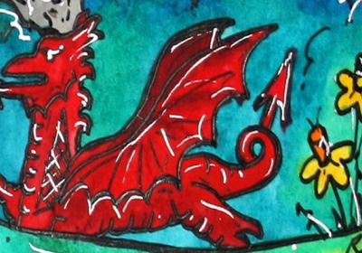](https://www.google.co.uk/url?sa=i&url=https%3A%2F%2Fwww.open.edu%2Fopenlearn%2Flanguages%2Fwelsh%2Fhafan-what-do-you-know-about-welsh-language-and-culture&psig=AOvVaw2viRTLJxk3amQeUc6ZJQst&ust=1590493974126000&source=images&cd=vfe&ved=0CAIQjRxqFwoTCPC7pPf5zukCFQAAAAAdAAAAABAD) [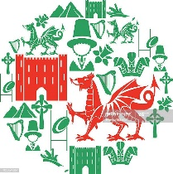](https://www.google.co.uk/url?sa=i&url=https%3A%2F%2Fwww.gettyimages.com%2Fillustrations%2Fwelsh-culture&psig=AOvVaw2FqaHCm_SPfpZGgUKJWTgz&ust=1590494023217000&source=images&cd=vfe&ved=0CAIQjRxqFwoTCLDf3JH6zukCFQAAAAAdAAAAABAD) [](https://www.google.co.uk/url?sa=i&url=https%3A%2F%2Fcopronet.wales%2Fevent%2Four-future-wales-workshop%2F&psig=AOvVaw28jJBGdXqyQC1F-7vUbu6J&ust=1590494089598000&source=images&cd=vfe&ved=0CAIQjRxqFwoTCOicl7L6zukCFQAAAAAdAAAAABAE)

Uned 1 : Cofiwch (Remember you will be expected to refer to this unit as part of your unit 1 oral examination. You will need to explain the content of your coursework, your reason for choosing the subject, the various stimuli used, your research and refer to the individual components of the pack)

Before starting to consider possible topics for your unit 2 work it’s a good idea to get to know more about Wales as a country? What do you know about it’s history? What do you know about it’s famous people? What do you know about it’s traditions? Now is a good time to find out more.

**Llinell Amser Cymru**

[llinell amser](http://www.llinellamser.cymru/web) (A timeline showing the important dates and events in Welsh history, which will be an integral part of the A level units)

**Beth?**

Events like …

* Merched Beca / Rebecca Riots
* Y Mabinogion
* Cilmeri
* Tynged yr Iaith
* Tryweryn
* Sefydlu S4C
* Llywodraeth Cymru
* Targed 2050

**Pwy?**

People like …

* Owain Glyndwr
* Llywelyn ap Gruffydd
* Hedd Wyn (Ellis Humphrey Evans)
* Aneirin Bevan
* Saunders Lewis
* Trefor & Eileen Beasley
* Gwynfor Evans
* Mererid Hopwood

**ENWOGION CYMRU**

(Famous Welshmen and women)



**BEIRDD CYMRU** (Welsh Poets)

[Poets](https://parallel.cymru/poets/) (Click onto a bilingual introduction to the poets of Wales and their poetry)

You will study 5 poems during the course – 5 poems by 5 different poets which will offer an insight into Welsh literature. Maybe poetry is not for you but the message from the poet may relevant to you.

The poems are:

|  |  |  |
| --- | --- | --- |
| “Caerdydd”  gan Iwan Rhys  [Iwan Rhys Morus (@irmorus1) | Twitter](https://www.google.co.uk/url?sa=i&url=https%3A%2F%2Ftwitter.com%2Firmorus1&psig=AOvVaw0a_KgdZaZWED_7OQrZGhn3&ust=1590569257147000&source=images&cd=vfe&ved=0CAIQjRxqFwoTCLjy98mS0ekCFQAAAAAdAAAAABAS) | “Lerpwl”  gan Grahame Davies  [Poetry by Grahame Davies from Seren Books - YouTube](https://www.google.co.uk/url?sa=i&url=https%3A%2F%2Fwww.youtube.com%2Fwatch%3Fv%3Dd99812Ouo_M&psig=AOvVaw1g4TGyPkgx1FB64Cp2PAO8&ust=1590569395824000&source=images&cd=vfe&ved=0CAIQjRxqFwoTCMim2fKS0ekCFQAAAAAdAAAAABAD) | “Twyll”  gan Myrddin ap Dafydd  [Myrddin ap Dafydd - Wicipedia](https://www.google.co.uk/url?sa=i&url=https%3A%2F%2Fcy.wikipedia.org%2Fwiki%2FMyrddin_ap_Dafydd&psig=AOvVaw0d3tZWflz18XZgo3u5aE67&ust=1590569195845000&source=images&cd=vfe&ved=0CAIQjRxqFwoTCKC5i5OS0ekCFQAAAAAdAAAAABAD) |
| “Newyddion”  gan Tudur Dylan Jones  [Tudur Dylan Jones - Wicipedia](https://www.google.co.uk/url?sa=i&url=https%3A%2F%2Fcy.wikipedia.org%2Fwiki%2FTudur_Dylan_Jones&psig=AOvVaw2hLAcfKRpKt0oMAejESBFs&ust=1590569149664000&source=images&cd=vfe&ved=0CAIQjRxqFwoTCNifh_6R0ekCFQAAAAAdAAAAABAD) | “Dim ond Serch”  gan Gwion Hallam  [Dementia and the Arts: A Day of Discussion - Canolfan Ysgrifennu ...](https://www.google.co.uk/url?sa=i&url=https%3A%2F%2Fwww.tynewydd.wales%2Fcourse%2Fdementia-arts-day-discussion%2F&psig=AOvVaw3deBzLeVSxjMo_xWoyS_He&ust=1590569069479000&source=images&cd=vfe&ved=0CAIQjRxqFwoTCOCzmt6R0ekCFQAAAAAdAAAAABAD) | Mae nodiadau ar y cerddi ar wefan HWB ac ar wefan CBAC.  [Nodiadau'r 5 cerdd](https://astudiollenyddiaeth.cymru/#/main-menu) |

Geirfa ddefnyddiol (Useful vocab)

|  |  |  |  |
| --- | --- | --- | --- |
| cerdd | cerddi | barddoniaeth | bardd |
| poem | poems | poetry | poet |
| pennill | penillion | odl | geiriau |
| verse | verses | rhyme | Words |
| llinell | llinellau | byr | hir |
| line | lines | short | long |
| rhythm | ailadrodd | cyflythreniad | trafod |
| rhythm | repetition | alliteration | to discuss |
| dechrau | diwedd | iaith | neges |
| start | end | language | message |

Sut alla i baratoi?

How can I prepare?

* Revise language and grammar. Try out the exercises in this booklet. Take time to create your own rap or resource to remember rules for the future.
* Set aside a specified time each week to communicate with a group of friends through the medium of Welsh – text, snapchat, Instagram … Make it fun. You don’t have to be perfect grammatically, you just need to make a conscious effort to use Welsh.
* Watch the film Patagonia. Look at the background themes but more than anything take time to enjoy the film. Get to know the characters. You have two women taking journeys – one to find her past and the other to find her future.
* Watch some of the YouTube links and look at that “Llinell Amser” to gain a better understanding of the history of Wales – it’s struggles and success stories.
* Start to think about possible themes for unit 2, an area you would enjoy researching and working on.
* Aim to be an active part of that target of a million Welsh speakers by 2050, and to be part of our bilingual society.

Yn olaf, beth am edrych ar hen bapurau?

Lastly, why not take a look at a past paper?

* [Papur 2019](http://pastpapers.download.wjec.co.uk/s19-2027-01.pdf)
* [Papur 2018](http://pastpapers.download.wjec.co.uk/s18-2027-01.pdf)

**Dwy Iaith = Dwywaith y Cyfle**

[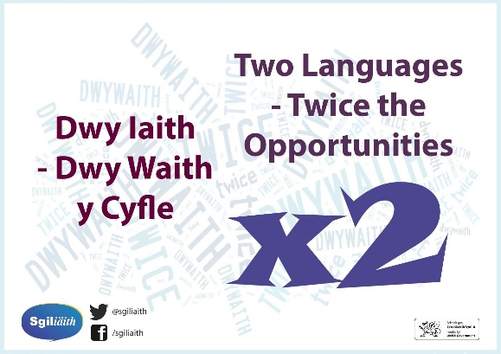](https://www.google.co.uk/url?sa=i&url=https%3A%2F%2Fwww.pinterest.co.uk%2Fpin%2F472596554622623911%2F&psig=AOvVaw1p9iYGBlNOzbYV-r-X-kWB&ust=1590498104882000&source=images&cd=vfe&ved=0CAIQjRxqFwoTCOji1a6Jz-kCFQAAAAAdAAAAABAD)