AS Level Chemistry

A guide to help you prepare yourself for studying AS Level Chemistry

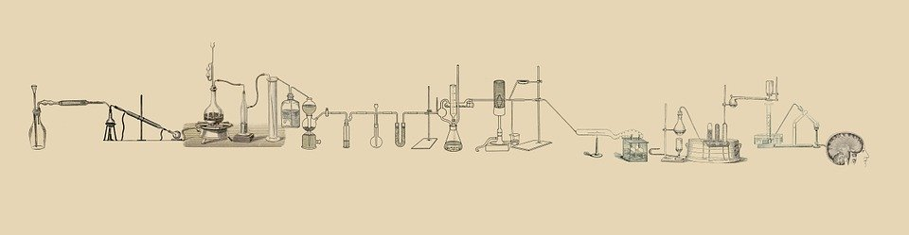

Before starting AS level Chemistry
It is really important that you thoroughly understand the core principles of Chemistry that you studied at GCSE as it will be expected that you know how to confidently and competently complete questions of this level from GCSE during the AS level course.
In the table below are some links to resources that will help you refresh and build upon your GCSE studies.

Area of Study | Link
Mole Calculations | https://www.youtube.com/watch?v=dO0kjefmunk
% Yield | https://www.youtube.com/watch?v=--3gzdOpz9I
Hydrocarbons | https://www.youtube.com/watch?v=S5et1nz_5po
Concentrations | https://www.youtube.com/watch?v=x4QxYDyHst0
Chemical Formula | https://drive.google.com/drive/folders/1dwS-Ah-UYBECXcfL7RA7N9FwGO6_DBwm
Relative Molecular Mass | https://drive.google.com/drive/folders/11m4ra6GaOeb24JwB0qhEnRyXahZbMWlT
Balancing Equations | https://drive.google.com/drive/folders/1dwS-Ah-UYBECXcfL7RA7N9FwGO6_DBwm

Open University Courses
- Discovering Chemistry
Covering balancing equations, the structure of compounds, the periodic table, isotopes and atomic and mass numbers
https://www.open.edu/openlearn/science-maths-technology/chemistry/discovering-chemistry/content-section-overview?active-tab=description-tab

- The Science of Alcohol
Covering fermentation, the production of spirits such as Gin, alcoholic drink flavouring and the effects of alcohol on the body.

https://www.open.edu/openlearn/science-maths-technology/the-science-alcohol/content-section-overview?active-tab=description-tab

- The Molecular World
Covering the properties of molecules and organic chemistry.
https://www.open.edu/openlearn/science-maths-technology/chemistry/the-molecular-world/content-section-0?active-tab=description-tab

Additional Resources

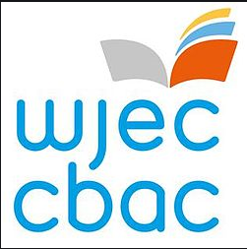

For Open University and Swansea University resources and courses.

https://hwb.gov.wales/distance-learning/resources/post-16/

For Chemistry Past Papers
https://www.wjec.co.uk/qualifications/chemistry-as-a-level/#tab_pastpapers
For the Chemistry specification
https://www.wjec.co.uk/qualifications/chemistry-as-a-level/#tab_overview

