AS Level
English Language and Literature

AS in English Language and Literature
In studying this AS level you will have opportunities to learn about the wide range of contexts that affect a piece of writing, such as the life experiences of the author, the social issues of the time of writing, and the historical events that were unfolding.
The WJEC AS in English language and literature is a really interesting course, allowing you to study a great range of literature, focus on how language choices affect our appreciation of texts, and it also gives you the opportunity to write creatively.

You will be supported in pulling together your understanding of literary devices and language issues such as vocabulary choices, the form of writing, and its structure. Not only will you do all of this through reading and study but also through creating your own written pieces, applying all you are learning about the ways language works.

The AS units require you to:
- Take 2 exams
- The first one requires you to have studied an anthology of poetry
- In the exam you will compare one of the poems you have studied with an unseen poem
- You will then be asked to write two pieces of writing and to create a commentary on them
- The second exam requires you to have studied a set play and a set piece of non-literary prose writing (which is essentially a piece of writing that is true, that is not a piece of fiction)
- You will answer an extract question and write an essay on the play
- You will then write a more detailed essay on the non-literary
text

Section 1
What have you read?
How broadly have you read?
Why not try one or more of these…

Today I'm five. I was four last night going to sleep in Wardrobe, but when I wake up in Bed in the dark I'm changed to five, abracadabra.
Jack lives with his Ma in Room. Room has a single locked door and a skylight, and it measures ten feet by ten feet. Jack loves watching TV but he knows that nothing he sees on the screen is truly real - only him, Ma and the things in Room. Until the day Ma admits there is a world outside.
Devastating yet uplifting, Room by Emma Donoghue is a luminous portrait of a boundless maternal love.

One boy, one boat, one tiger . . . After the tragic sinking of a cargo ship, a solitary lifeboat remains bobbing on the wild, blue Pacific. The only survivors from the wreck are a sixteen-year-old boy named Pi, a hyena, a zebra (with a broken leg), a female orang-utan - and a 450-pound Royal Bengal tiger. The scene is set for one of the most extraordinary and best-loved works of fiction in recent years.

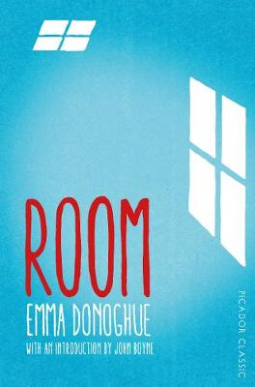

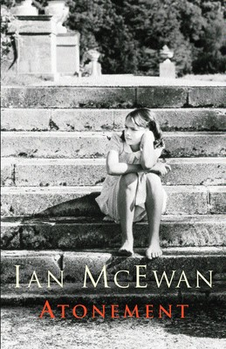
On the hottest day of the summer of 1935, thirteen-year-old Briony Tallis sees her sister Cecilia strip off her clothes and plunge into the fountain in the garden of their country house. Watching her too is Robbie Turner who, like Cecilia, has recently come down from Cambridge. By the end of that day, the lives of all three will have been changed for ever, as Briony commits a crime for which she will spend the rest of her life trying to atone.

Only Gatsby, the man who gives his name to this book, was exempt from my reaction – Gatsby who represented everything for which I have unaffected scorn. If personality is an unbroken series of successful gestures, then there was something gorgeous about him, some heightened sensitivity to the promises of life, as if he were related to one of those intricate machines that measure earthquakes ten thousand miles away.
The Great Gatsby is F. Scott Fitzgerald's brilliant fable of the hedonistic excess and tragic reality of 1920s America.
Young, handsome and fabulously rich, Jay Gatsby is the bright star of the Jazz Age, but as writer Nick Carraway is drawn into the decadent orbit of his Long Island mansion, where the party never seems to end, he finds himself faced by the mystery of Gatsby's origins and desires.
Beneath the shimmering surface of his life, Gatsby is hiding a secret: a silent longing that can never be fulfilled. And soon, this destructive obsession will force his world to unravel.

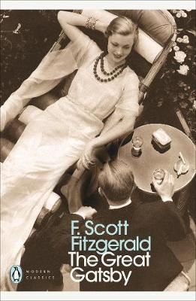

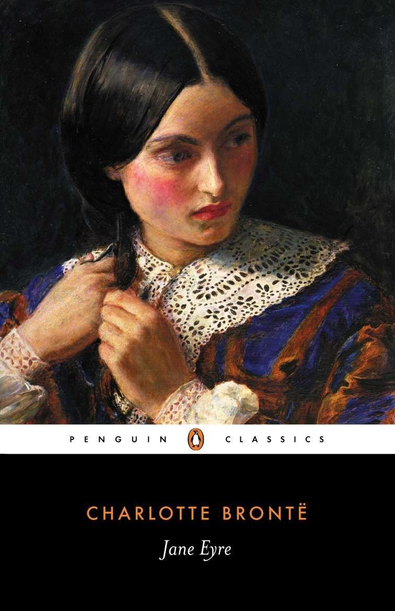
Jane comes from nothing but she desires everything life can offer her. And when she finds work as a governess in a mysterious mansion, it seems she has finally met her match with the darkly fascinating Mr Rochester. But Thornfield Hall contains a shameful secret - one that could keep Jane and Rochester apart forever. Can she choose between what is right, and her one chance of happiness?

Have a think about your reading:

Q: What is similar about all these books recommended?
A:They are all written in the first person narrative

Advantages | Disadvantages
- Get inside the narrator’s mind  - Personal  - Can evoke sympathy or empathy  - Feels more reliable…but… | - Narrows the experience  - Difficult to get a picture of the  narrator’s physicality  - Biased  - Unreliable
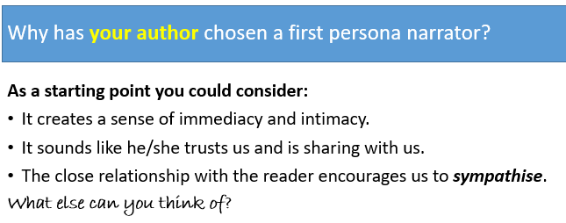

Section 2: Movies
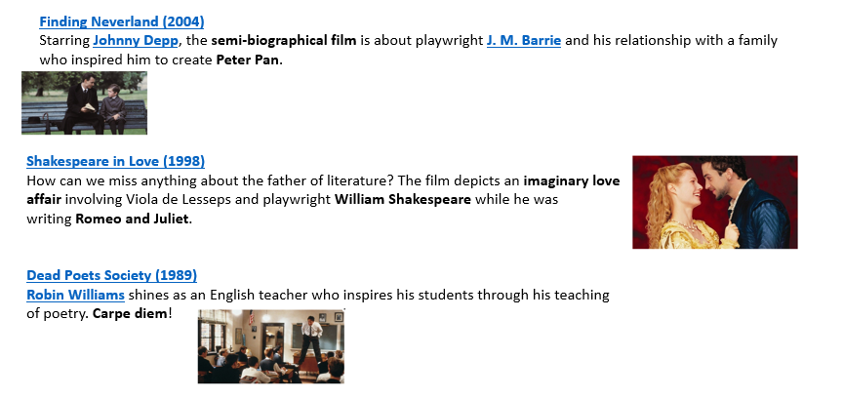
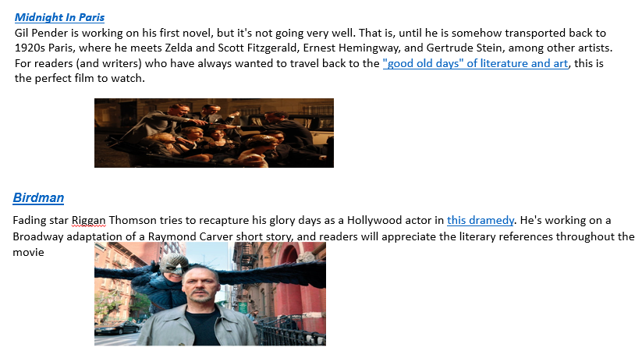

Section 3: Some Terminology
In studying this AS, you will need to recall terminology from GCSE, and use it to help you analyse and explain your understanding of a range of texts. There will also be new terminology to learn! This task gives you a taster of some of the terms you will recall and encounter:
Commonly used Language terms
Have a go at this quiz which contains some terminology you will be used to using from GCSE and some that is new

In the first column you have some commonly used linguistic terms. Some will be familiar and some will be completely new! They are matched with the WRONG definition but the RIGHT example. See if you can work out the correct definition for each term.

Term | Definition | Example that matches the term
Narrative stance | A group of words within a text relating to the same topic. | Charlene sat with her back facing the fat man. She absorbed the smells around her and began to feel panic.
Semantic field | A form of list in which there is no conjunction, such as ‘and’ or ‘but’ … | Tyre, wheel, oil, hub-cap
Prosodic features | The viewpoint adopted by the  character telling the story. | You really are getting on my nerves now, get it?
Context | Simple words that are commonly used within our language. | Ladies and gentlemen we are gathered here today to welcome the arrival into this world of …
Paralinguistic features | The layout of a text with use of such features as typeface, colour, size of font. | I’m telling you, tee hee, snigger, snigger – it went like this.
Asyndetic list | The vocal aspects of speech (volume, stress, intonation,) that help to convey meaning. | Trees, cars, people, fields, clouds rolling by, …
Expostulation | Non-verbal aspects of communication such as intonation or pausing, which help to work alongside language to convey meaning. | Tits, bugger, piss off, Jesus Christ!
High frequency words | The social situation including  audience and purpose in which language is used. | And, but, when, it, they, the, will, can.
Graphology | Language that may be used in  informal conversation. | Big Bold Statements come in crazy forms!!
End-stopped line | Continuity from one line of verse to the next without punctuation to end stop.  . | O my life is so drenched in pain.  If only I were a cat.
Phonological pattern | The sounds of the words as they  are said aloud creating a recognisable sound shape within the text. | Shooting shivers boomed within my rattling skull.
Enjambment | Expletives, swearing, slang. | Dreary mess that is my life  Doth fuel my rage with thoughts of death.
Tetrameter | Where words have been omitted within a sentence. | I swim amid the grass of youth,  I laugh amid the race of age.
Elliptical sentence | A line of verse with a piece of  punctuation at the end to indicate a pause | Said like yeh, but no, but yeah like.
Colloquialism | A line with four stressed syllables. | You’re sure gonna get on her wick if you do that again. Awesome.

Section 4: Get Ahead !
It will give you a great head-start for your AS study if you are able to get to grips with some aspects of the study of language and literature. Here are some ideas and tasks as starting points:

What adverbs are and the different jobs they do
Focused analysis of a piece of text

The different types of nouns

Context: what it is and how it affects a reader’s experience of the text

Use the internet to help you research these different types of noun:
Common, abstract, collective, concrete.
Make some notes about the different types.
Then, have a look at these quotations, and highlight the abstract nouns. Annotate them to show the meaning and effect of the use of the abstract noun, in your view.
Then, write a paragraph explaining what you think the challenges are when analysing the meaning and effect of abstract nouns in a piece of writing.
- Love is an irresistible desire to be irresistibly desired." - Robert Frost

- "I do not think that there is any other quality so essential to success of any kind as the quality of perseverance. It overcomes almost everything, even nature." - John D. Rockefeller

- "Creativity requires the courage to let go of certainties." - Erich Fromm

- "Justice means minding one's own business and not meddling with other men's concerns." – Plato

- "Men say they love independence in a woman, but they don't waste a second demolishing it brick by brick." - Candice Bergen

- "Fear is the main source of superstition, and one of the main sources of cruelty. To conquer fear is the beginning of wisdom." - Bertrand Russell

- "The important thing is not to stop questioning. Curiosity has its own reason for existing." - Albert Einstein

- "Anger is the enemy of non-violence and pride is a monster that swallows it up." - Mahatma Gandhi
Adverbs:
Use this web-page to make notes on what adverbs are and how they are used to provide context in writing. There are some examples to work with at the end of the page.
https://www.gingersoftware.com/content/grammar-rules/adverb/

Context
In studying this AS level you will have opportunities to learn about the wide range of contexts that affect a piece of writing, such as the life experiences of the author, the social issues of the time of writing, and the historical events that were unfolding.
For example, if you study Truman Capote’s ‘In Cold Blood’, you will need to understand the lives of people living in small-town America in the late 1950’s. You will need to understand the attitudes held by many people of the times, for example about people of different races; the status of men and women; family life and American values.

Watch these short promotional films from the 1950s. What do they suggest to you about this place and time?
https://www.youtube.com/watch?v=R6bHs8Vm3EQ
https://www.youtube.com/watch?v=Jqe4W08124M

Section 5: Analysis of a piece of text

Read the first section of the opening chapter of ‘In Cold Blood’:

The village of Holcomb stands on the high wheat plains of western Kansas, a lonesome
area that other Kansans call "out there." Some seventy miles east of the Colorado
border, the countryside, with its hard blue skies and desert-clear air, has an atmosphere
that is rather more Far West than Middle West. The local accent is barbed with a prairie
twang, a ranch-hand nasalness, and the men, many of them, wear narrow frontier
trousers, Stetsons, and high-heeled boots with pointed toes. The land is flat, and the
views are awesomely extensive; horses, herds of cattle, a white cluster of grain elevators rising as gracefully as Greek temples are visible long before a traveler reaches them.
Holcomb, too, can be seen from great distances. Not that there's much to see -
simply an aimless congregation of buildings divided in the center by the main-line
tracks of the Santa Fe Rail-road, a haphazard hamlet bounded on the south by a brown
stretch of the Arkansas (pronounced "Ar-kan-sas") River, on the north by a highway,
Route 50, and on the east and west by prairie lands and wheat fields. After rain, or when snowfalls thaw, the streets, unnamed, unshaded, unpaved, turn from the thickest dust into the direst mud. At one end of the town stands a stark old stucco structure, the roof of which supports an electric sign - DANCE - but the dancing has ceased and the advertisement has been dark for several years. Nearby is another building with an irrelevant sign, this one in flaking gold on a dirty window - Holcomb Bank. The bank closed in 1933, and its former counting rooms have been converted into apartments. It is one of the town's two "apartment houses," the second being a ramshackle mansion known, because a good part of the local school's faculty lives there, as the Teacherage.
But the majority of Holcomb's homes are one-story frame affairs, with front porches.
Down by the depot, the postmistress, a gaunt woman who wears a rawhide
jacket and denims and cowboy boots, presides over a falling-apart post office. The
depot itself, with its peeling sulphur-colored paint, is equally melancholy; the Chief, the
Super-Chief, the El Capitan go by every day, but these celebrated expresses never pause
there. No passenger trains do - only an occasional freight. Up on the highway, there are
two filling stations, one of which doubles as a meagerly supplied grocery store, while
the other does extra duty as a cafe - Hartman's Cafe, where Mrs. Hartman, the
proprietress, dispenses sandwiches, coffee, soft drinks, and 3 .2 beer. (Holcomb, like all
the rest of Kansas, is "dry.")
And that, really, is all.

How does this opening create a sense of Holcomb as an isolated town, trapped in its past?

Section 6: What is a non-fiction novel?

Truman Capote boasted that he had created a new kind of book, a ‘non-fiction novel’ by writing ‘In Cold Blood’ which tells the story of the murder of the Clutter family by two young men.

Each of these aspects features stylistically in the book. Can you work out which are generally regarded as typical of works of fiction and which are typical of works of non-fiction?
Metaphors and similies
Dialogue
Facts and figures
Detailed, atmospheric descriptions
Reference to real people and places
Adverbs to give sense of time, place, manner
Descriptions through personification
Hyperbole
Litotes
Irony and sarcasm
Alliteration
Pathetic fallacy
Symbolism
Quotations from actual people
Prepositions
Chronological structure

Section 7: Creative Writing
Unit 1 will ask you to write creatively. In order to do this you will need to demonstrate your awareness of ;
Genre
Audience
Purpose
You will also need to think of linguistic and /or literary features that will help you achieve your outcome.

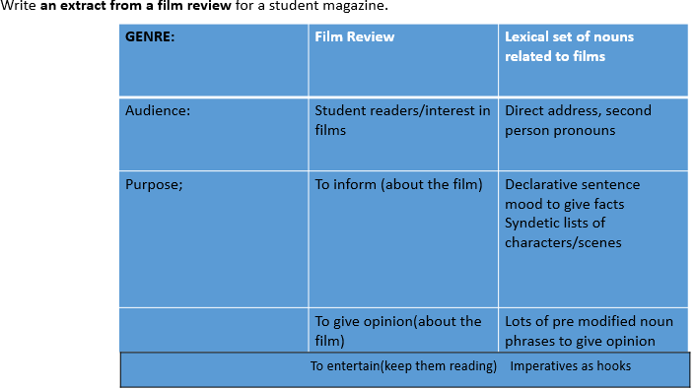

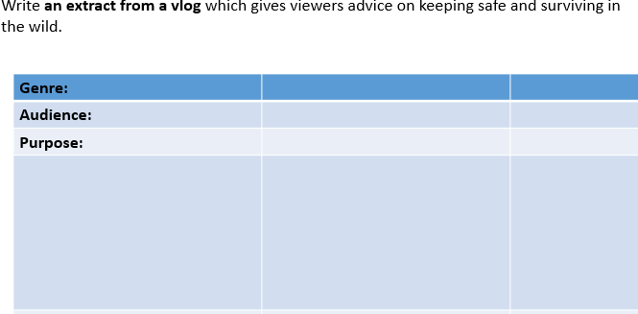

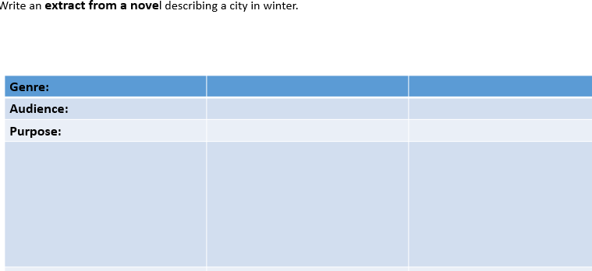
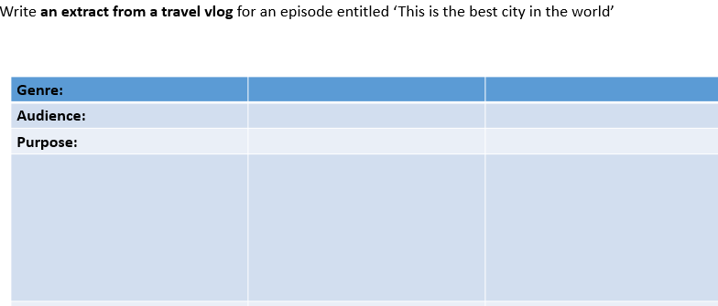
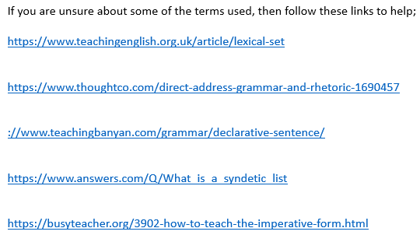

Section 8: Social Media and Ted Talks
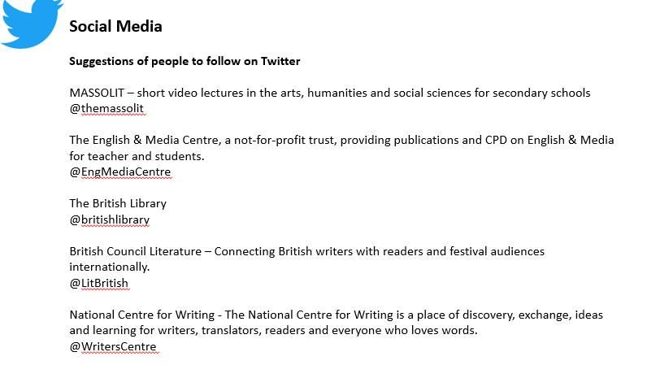
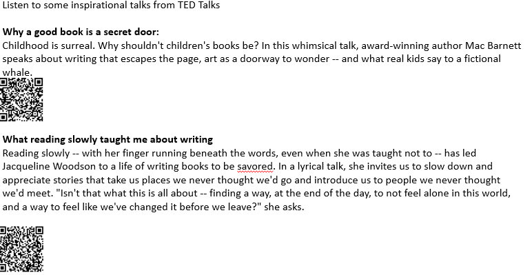
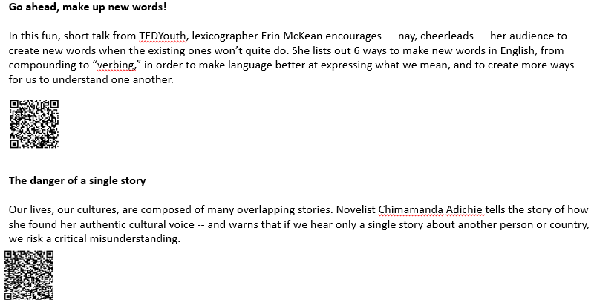

Section 8: Some General Tasks to get you ready!

